**Objectives:**

* Solve trigonometry questions, relating to **right triangles**, using these ratios:

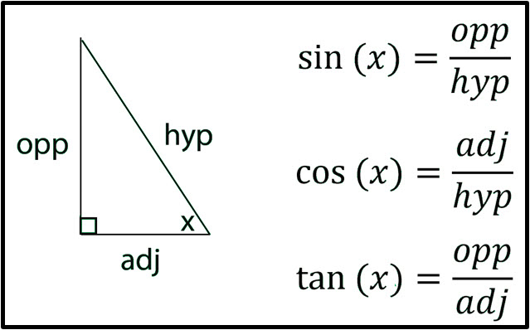

* Use the inverse sine (arcsin), inverse cosine (arccos), and inverse tangent(arctan) to find the measure of an angle in a triangle.
* Know that an **oblique** triangle is a triangle that does **not** contain a right angle.
* Use the **Law of Sines** to solve a right triangle **or** an oblique triangle when given AAS, ASA, or SSA (Ambiguous Case).

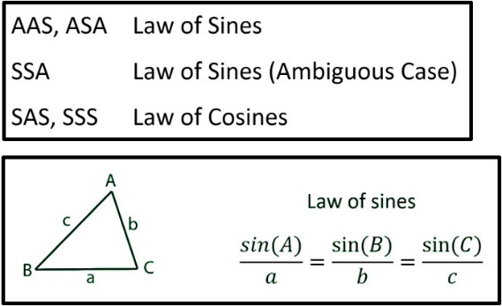

* Use the **Law of Cosines** to solve a right triangle **or** an oblique triangle when given SAS or SSS.

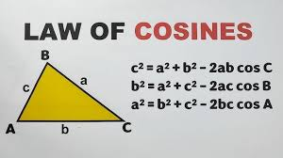

* Be able to find the areas of both right and oblique triangles.
* Use Area = 0.5(base)(height) for right triangles and oblique triangles when you know the base and the height.
* Use The Law of Sines Area Formula for oblique triangles when you know 2 sides and an included angle (SAS).
* Use Hero’s (Heron’s) Formula when you know all 3 sides (SSS).

**Monday, 3.10.25**

**Homework Check and Discussion of the previously assigned homework:** 9 problems using The Law of Cosines (See Google Classroom for a copy of these problems if you were absent on Friday.)

**Class Work/Homework: Review ___ The Law of Sines and The Law of Cosines** **(To be received in class and posted in Google Classroom).**

**WEDNESDAY (3.12.25)**

**Homework Check and Discussion of the previously assigned review.**

**Discuss how to find the areas of both right and oblique triangles.**

**Look at this link:** https://www.mathsisfun.com/algebra/trig-area-triangle-without-right-angle.html

**Class Work/Homework: Finding the Areas of Triangles (To be received in class and posted in Google Classroom).**

**Friday, 3.14.25**

**Discuss the previously assigned work:** Finding the Areas of Triangles.

**Take Home Project:** *Finding the Area.* Be sure to explain your solution.

**Due Monday, March 24.**